$40 1 square tile

Enclosure included

1024 LEDS

7.5” x 7.5”

[32 x 32 LED Matrix](https://www.sparkfun.com/products/12584?gclid=Cj0KEQjwoYi4BRDF_PHHu6rI7NMBEiQAKZ-JuPUr-ki9OWxJdkixmBN6H3Q-SsSnuNPiZaltOT0XA6EaAtcm8P8HAQ)

STRIP LEDS

$8.99 for 300 leds

Not as close together

Only LEDS.

[300 leds](http://m.lightinthebox.com/en/5m-5050-smd-300-rgb-led-strip-light_p291344.html?currency=USD&litb_from=paid_adwords_shopping&utm_source=google_shopping&utm_medium=cpc&adword_mt=&adword_ct=73694390572&adword_kw=&adword_pos=1o1&adword_pl=&adword_net=g&adword_tar=&adw_src_id=1465939714_290318092_26701180492_aud-83346267755:pla-193317840532)

# Differentiate Needs vs. Wants

* Display is major cross between both issues.
* Professor Tekamp has display that works perfectly and he is happy with but by building our own display we can complicate our project which currently is a major issue.
* Professor Tekamp’s display is approximately 500 pixels while we could expand to 4000-6000 pixels with our own.
* Page 33 graphic is perfect here

# Exploring Project Boundaries

* Customer size
  + Professor Tekamp has size limitations in mind but we need more specifics.
* Power allotment from building
  + Using the strip LEDs is expandable to any size we want and we could possibly be told by the school that we cannot use more than a certain amount of power.

# Pre-assembled LED boards

* 32 x 32 dot matrix
* 1024 LEDs
  + Smaller then Strip LEDs
* 7.5” x 7.5”
* Enclosure included
* $40

# Strip LEDs

* Any size we want
* Any amount of LEDs we want
  + Larger bulbs
* LEDs will sit further apart so display would be much larger without having more LEDs.
* We must build mounting display as well.
* 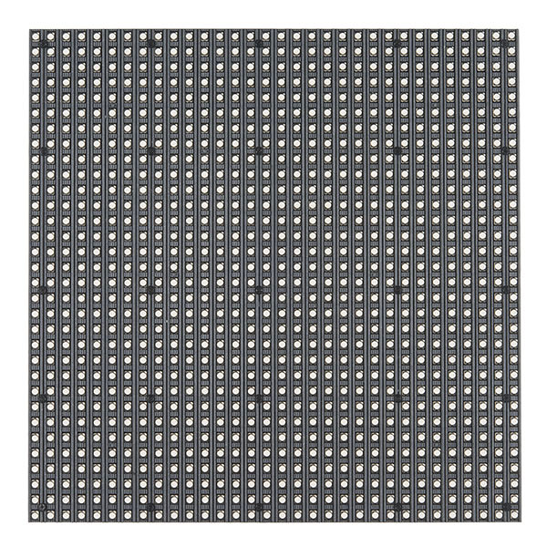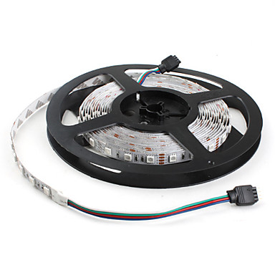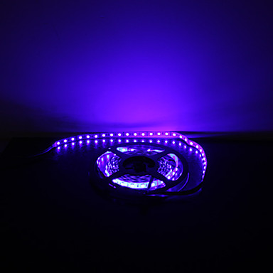$8.99 per 300